PRESIDENT  Russ Heiling  Sherburne Co. Surveyor  13880 Business Ctr. Dr.  Elk River, MN 55330  763-765-3305 | 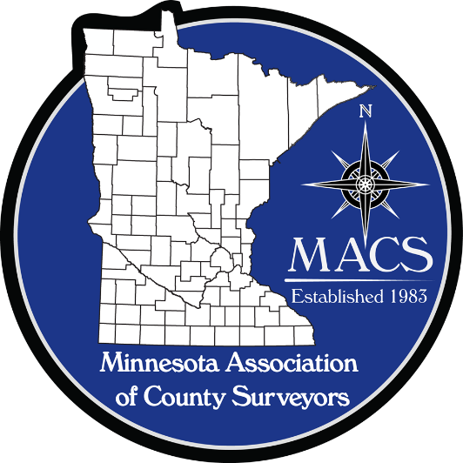 | SECRETARY/TREASURER  James Hentges  Scott County Surveyor  600 Country Trail East  Jordan, MN 55352  952-496-8362
PRESIDENT ELECT  Chuck Gitzen  Anoka Co. Surveyor  2100 3rd Ave. N., Rm 224  Anoka, MN 55303  763-324-3101 |  | DIRECTOR  Eric Schmitt  Houston County Surveyor  304 South Marshall Street  Caledonia, MN 55921  507 725-5814
PAST PRESIDENT  Tim Eklund  Deputy Hennepin  County Surveyor  300 South 6th Street  Minneapolis, MN 55487  612-348-2336 |  | DIRECTOR  Robin Mathews  Pine County Surveyor  405 Airport Rd. NE  Pine City, MN 55063  320-216-4205

www.macsinfo.org

MINUTES OF MEETING (APPROVED)
Minnesota Association of County Surveyors
April 17th, 2019
MACS Meeting at Washington County.
Russ Heiling called the meeting to order at 10:00 AM
Attendance: Russ Heiling, Tim Eklund, Robin Mathews, Pat Veraguth, Jim Hentges, Preston Dowell, Chuck Gitzen, Brian Praske, Eric Schmitt, Mark Severtson, Mike Welling, Warren Delles, Steve Jobe, Jay Wittstock, Chris Mavis, Pete Jenkins, Dan Baar, Devin Ball, Adam Earnex, Ryan Olson, Mike McGuire, Bryan Balcombe.
Approval of Minutes: February 14th 2019. Motion by Robin Mathews. Second by Tim Eklund . Approved.
Reports:
Secretary/Treasurer: Jim Hentges provided information on MACS memberships numbers. Currently 30 Voting members and 7 Affiliate members. Jim also provided information on MACS funds. Currently $19,886.64 in the account with an expense of $1,075.00 due to NACS for membership dues. Total remaining is $18,811.64.
Right of Way Manual: Brian Praske reported that the Right of Way Manual is pretty much ready to go. Brian stated they had received several comments after sending out for review that they are addressing.
AMC Representative: Tim Eklund updated the group. There was discussion on a state boundary project.
Education Committee: Steve Jobe informed group that he was going to give a presentation on the role of the County Surveyor to St. Cloud State University students.
Legislative Commission: Robin Mathews discussed hearing of possible future continuing education requirements for 2 hours of climate change education. Discussion on whether MSPS will have lobbyist this year.

Long Range Planning Committee: Russ Heiling discussed topics for fall seminar.
Manual Committee: Brian Praske updated group on status of Right of Way Manual. The committee is looking to finalize the manual by May 2nd.
Membership Committee: Steve Jobe reported that the map showing county surveyors has been updated. Steve noted a discussion on meeting times etc. for the group and how challenging it is for part time county surveyors to make a meeting during the regular working hours.
PLSS Committee: Pat Veraguth reported on a meeting with Morrison County. Pat also discussed status of PLSS Remonumentation funding. Pat also noted that the committee was meeting today after the MACS meeting.
Seminar Planning: Date for seminar has been set for October 31st at the Kelly Inn in St. Cloud. Russ Heiling asked about seminar topics and that any ideas for topics be sent to him. Robin Mathews suggested a possible topic regarding Road R/W statute 160. Group also discussed a 2 hour ethics session.
State Board Update: Dan Baar reported on several items from the board. Discussion on deregulation happening in other parts of the country. Dan provided handout regarding draft rules changes and changes to experience requirements for surveyors. There was lots of discussion on ways to get registered and ways to gain experience.
Laptop Computer purchase: Group discussed laptop computer purchase for association to have available for fall seminar. Jim Hentges to purchase computer before seminar.
Future Cities activities: Robin Mathews reported on the latest competition and reported that Robin, Steve Jobe and Pete Jenkins were judges. Steve Jobe suggested getting information on participating schools to work with and mentor for the competition. Tim Eklund suggested having Colleen from Future Cities Competition come to a MACS meeting. Tim will check with Colleen and see if that is possible. There was discussion on the general purpose and benefits of Future Cities Competition.
Territorial Maps Re-order: David Claypool has requested MACS re-order additional Territorial maps to give out at the Land Office during the Little Log House Antique Power Show in July. Motion by Russ Heiling to approve 600 dollars for maps to give out at the Land Office plus 300 dollars for maps for MACS to give out. Second by Steve Jobe. Motion approved.
Sandboxes: Russ Heiling talked to Nick Stewart about making another sandbox for events due to popularity of them. Nick estimated the cost to be about $2,500.00 for materials only. Russ will follow up with Nick on possibilities.
Cemetery Platting: Connie Villari presented information on cemeteries and cemetery platting. Statutes 241.16, 246.33, 306, 307, 365.26, 525.14. Connie noted that some of the statutes are more stringent than others. Connie discussed requirements for various types of cemeteries. Statutes are vague to allow flexibility. There was lots of discussion on different forms of cemetery platting and ways to accomplish. Suggestion for a place to submit samples of cemetery plats that can be used by others when they do cemetery plats.
NACS Conference: Russ Heiling attended the NACS conference and reported discussions on continuing education and educational requirements for surveyors. He reported that NACS and NACO are looking for funding for remonumentation activities. Russ said there were good panel discussions also.

Capital Display: Robin Mathews updated group on display at the capital. Robin suggested applying earlier for location of display to get more exposure. Robin said there wasn’t much traffic at the capital until after 10 am.
Wisconsin meeting: Mike Welling gave presentation on Wisconsin/Minnesota boundaries at bridge locations in Washington County that he was involved with. Mike talked about challenges to establish the boundary. Pete Jenkins mentioned Minnesota/Wisconsin Boundary Commission and getting that going again to address the boundary. Jay Wittstock asked who can establish state boundaries and is that a consideration. Lots of discussion on topic.
Definition of Land Surveying: Bryan Balcombe initiated discussion on the current definition of Land Surveying and possible changes. There was discussion on changes from the definition adopted in 2014 and what new language would be. Consensus of the group is there is a lot to consider before moving forward with changes.
Meet me at the corner: Robin discussed having another Meet me at the corner session for GIS/LIS again this year. Robin requested some MACS mugs to give out and how many do we have available. Motion by Robin Mathews to order more mugs. Second by Steve Jobe. Motion approved.
Platting Manual: Tim Eklund asked about updating the Platting Manual. Motion by Tim Eklund to create a joint platting manual committee with MSPS to update manual. Second by Russ Heiling. Motion approved.
Life Members: Motion by Robin Mathews to add Larry Hoium, retired Anoka County Surveyor as a Life member of MACS. Second by Tim Eklund. Motion approved.
MnDOT Technical Conference: Robin talked about the MnDOT Survey Technical Conference and the opportunity for MACS to reach out to this group of people. Pete Jenkins noted there have been requests for more construction related topics. There was discussion on a possible panel discussion topic regarding experience requirements for land surveyors.
Next Meeting: Meeting at Houston County.
Other: Preston Dowell discussed activities at the Governors Geospatial Council. Preston reported that there are positions coming up on the council and that a new position for Land Surveyors was created.
Mike Welling presented a Certificate of Appreciation for all the work has done for MACS over the years. Mike is retiring. Congratulations Mike.
Adjourn: Motion by Mike Welling. Second by Russ Heiling. Meeting adjourned.

