PRESIDENT  Tim Eklund  Dpty. Hennepin Co. Surveyor  300 South 6th Street  Minneapolis, MN 55487  612-348-2336 | 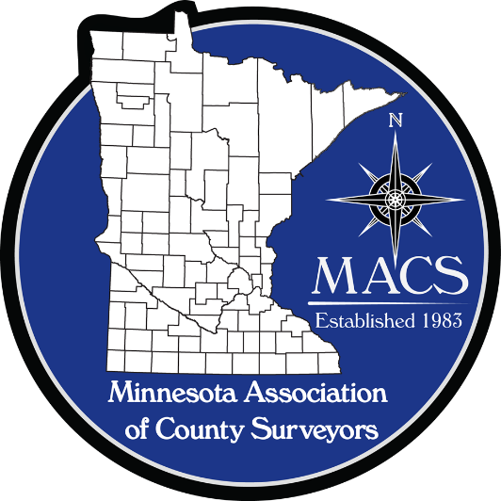 | SECRETARY/TREASURER  James Hentges  Scott County Surveyor  600 Country Trail East  Jordan, MN 55352  952-496-8362
PRESIDENT ELECT  Russ Heiling  Sherburne Co. Surveyor  13880 Business Center Drive  Elk River, MN 55330  763-765-3305 |  | DIRECTOR  Eric Schmitt  Houston County Surveyor  304 South Marshall Street  Caledonia, MN 55921  507 725-5814
PAST PRESIDENT  Patrick Veraguth  Douglas County Surveyor  536 Willow Drive  Alexandria, MN 56308  320-762-2964 |  | DIRECTOR  Nick Stewart  St. Louis County Surveyor  7823 Highway 135 East  Virginia, MN 55792  218-742-9823

www.macsinfo.org

MINUTES OF MEETING (APPROVED)
Minnesota Association of County Surveyors
February 14, 2019
MACS Meeting at MSPS Annual Meeting.
Tim Eklund called the meeting to order at 9:45 AM
Attendance: Russ Heiling, Tim Eklund, Robin Mathews, Pat Veraguth, Jim Hentges, Preston Dowell, Scott Marlin, Chuck Gitzen, Brian Praske, Eric Schmitt, Todd Tollefson, Janele Fowlds, Gary Hopko, Jason Blommel, Dick Walter, Tammy Mauss, Ben Madsen, Terry VanHout, Mark Severtson, Dan Bueltel, Ryan Miller, Chad Conner, Nick Stewart, Mike Welling, Scott Tuchtenhagen, Dan McAninch.
Approval of Minutes: September 11th, October 31st, December 4th 2018. Motion by Robin Mathews. Second by Eric Schmitt . Approved.
Reports:
Secretary/Treasurer: Jim Hentges provided information on MACS memberships numbers. Currently 30 Voting members and 7 Affiliate members. Jim also provided information on MACS funds. Currently $19,886.64 in the account with an expense of $1,075.00 due to NACS for membership dues. Total remaining is $18,811.64.
Right of Way Manual: Brian Praske reported that the Right of Way Manual is pretty much ready to go. Brian stated they had received several comments after sending out for review that they are addressing.
AMC Representative: Tim Eklund updated the group. Tim said the sandbox display was a big hit at the AMC Conference. Tim also reported that MACS could be involved on AMC committees if we are

interested. Possibly the AMC Transportation and Infrastructure Committee. Tim will send out a link to the AMC website for more explanation.
Russ Heiling had received some “Get Kids into Surveying” posters that he provided to anyone who was interested in them.
Robin Mathews provided a NCEES Committee report. Robin stated that some of the PLS states felt that there are not enough PLSS questions in the exam.
Education Committee: Scott Marlin and Eric Schmitt met with Eric Fuller at SCSU to go over scholarship applications. They are working to try to get more applicants to apply and reviewing applications to come up with a more efficient scoring of applications.
MLS Foundation: Scott Marlin noted that the auction for the MLS Foundation will be on line and not a live auction this year.
New Business:
Meeting Dates: Dick Walter asked about hosting a meeting in Houston County this year. We could have a field trip to the Initial Point Monument and Lee’s Monument after the meeting.
Minnesota/Wisconsin Boundary: Tim Eklund discussed a Boundary project between Minnesota and Wisconsin that he became aware of. Tim had a brochure regarding the project. Tim asked group if MACS would be interested in participating in the project. Mike Welling discussed several projects that he is aware of and worked on at the Osceola Bridge, the Stillwater Lift Bridge, and the new bridge in Stillwater. Mike said the boundary has been determined in these areas. Tim said there is a meeting coming up and asked if anyone would be interested in attending. Pat Veraguth said he had done some work in Winona County and LaCrosse County Wisconsin while he was working in Winona. Wisconsin group hoped to have project completed by 2023. Tim reported that the meeting is on March 1st. Russ Heiling, Mike Welling and Todd Tollefson volunteered to attend meeting.
MACS Website: Mike Fangman would like to get any interesting maps that people have to put on the MACS website. Mike Welling asked about adding a list of MACS Officers to the website also.
Meet me at the Corner: Tim Eklund asked the group if they wanted to do another Meet me at the Corner presentation this fall again. Scott Marlin said the GIS/LIS group contacted him to see if we could provide the presentation at the GIS/LIS conference again. Preston Dowell discussed the event from last year and said it was very successful. Scott Marlin said there would be a good location to do it at this years’ event in St. Cloud.
505 Mylars: Chris Mavis discussed some issues they are seeing regarding plat mylars and people not using a photographic process to make them. There was discussion on the topic. Some of the County Surveyors do not police this process. Discussion on revising statute.
State Board Rules Changes: Chris Mavis and Preston Dowell discussed rules changes that do not allow experience gained before finishing school to count for experience in applying for survey licensure. Chris said MSPS has submitted some suggestions to the Board to review. The State Board would have to go through the rule making process again to change.

StemLink and Future Cities activities: Robin Mathews reported on these competitions and said it was very rewarding to mentor and judge these events. MACS continues to support these events. There was discussion on providing additional funding to teams that move on to the national level in these events.
Life Memberships: Robin asked about Life Memberships. He is collecting names for Life Membership consideration. Please contact him if you know of anyone for consideration.
Election of Officers:
President – Elect: Pat Veraguth nominated Chuck Gitzen . Second by Preston Dowell. Unanimously approved.
Director: Pat Veraguth nominated Robin Mathews. Second by Tim Eklund. Unanimously approved.
Secretary/Treasurer: Tim Eklund nominated Jim Hentges. Second by Dan McAninch. Unanimously approved.
Gavel passed to Russ Heiling. Russ presented Certificate to Tim Eklund for service as President. Russ talked about the next year. Russ talked about Meet me at the corner event, MACS budget, and possible MACS meetings in Morrison/Mille Lacs Counties.
Duane Bonnema and Dan Bueltel talked about the road authority responsibility to maintain section corners. Robin suggested putting an article in the news letter sent out by the State Board regarding these responsibilities.
Adjourn: Tim Eklund motion to adjourn. Eric Schmitt second. Meeting adjourned at 11:20 am.

