PRESIDENT  Tim Eklund  Dpty. Hennepin Co. Surveyor  300 South 6th Street  Minneapolis, MN 55487  612-348-2336 | 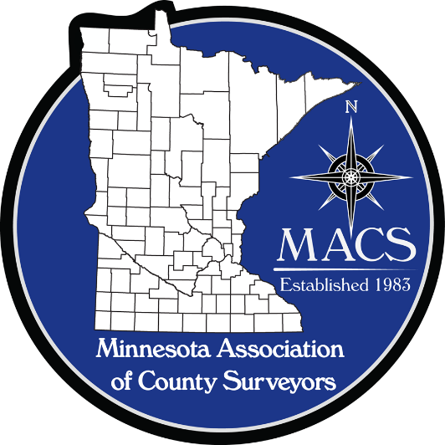 | SECRETARY/TREASURER  James Hentges  Scott County Surveyor  600 Country Trail East  Jordan, MN 55352  952-496-8362
PRESIDENT ELECT  Russ Heiling  Sherburne Co. Surveyor  13880 Business Center Drive  Elk River, MN 55330  763-765-3305 |  | DIRECTOR  Eric Schmitt  Houston County Surveyor  304 South Marshall Street  Caledonia, MN 55921  507 725-5814
PAST PRESIDENT  Patrick Veraguth  Douglas County Surveyor  536 Willow Drive  Alexandria, MN 56308  320-762-2964 |  | DIRECTOR  Nick Stewart  St. Louis County Surveyor  7823 Highway 135 East  Virginia, MN 55792  218-742-9823

www.macsinfo.org

MINUTES OF MEETING (APPROVED)
Minnesota Association of County Surveyors
July 25, 2018
MACS Meeting at Goodhue County.
Tim Eklund called the meeting to order at 10:00 AM
Attendance: Steve Jobe, Russ Heiling, Tim Eklund, Robin Mathews, Pat Veraguth, Jim Hentges, Eric Schmitt, Mark Severtson, Brian Praske, Chris Mavis, Tammy Mauss, Dale Lempke, Mike Welling, Mike Fangman, Lisa Hanni, Dan Wormer, Corey Hughes, LaCrosse Co. Wisc., Bryan Meyer, LaCrosse Co. Wisc., Mark Netterlund, Barron Co. Wisc., Laurence Johns, Vernon Co. Wisc., Glen Schaefer, Wisc. DOT (Retired), Brenda Hemstead, Wisc. State Cartographer’s Office.
Approval of Minutes: May 10th, 2018. Motion – Robin Mathews. Second – Eric Schmitt. Approved.
Secretary/Treasurer Report: 41 Voting members and 6 Affiliate members. Currently have $20,706.20 in the bank account.
MACS Committees:
Education Committee: Steve Jobe informed group that SCSU Provost is not making any changes at this time (ie not getting rid of program) which is good. SCSU is still down 1 faculty member. Robin Mathews said that if anyone is interested in teaching a class to contact Eric Fuller. Wisconsin County Surveyors group said their organization also sent a letter of support for the survey program to SCSU.
Legislative Committee: Tim Eklund said the Hennepin County Torrens Examiner asked him to check with MACS to see if we have any suggestions for changes to Chapter 508 regarding Registered Land Surveys. The attorneys group is looking to update some sections of the Chapter. Mike Welling asked if the Registrar of Titles require a plat instead of an RLS. Lisa Hanni and Tim Eklund volunteered to monitor progress on any possible changes. Lisa also reported some possible changes on the excess right of way turn back process.

Membership Committee: Steve Jobe gave update. Steve noted that Dan McAninch is the new Crow Wing County Surveyor and asked if he has joined MACS. Jim Hentges said he has received membership application from Dan. Steve talked of the differences between full time County Surveyors and part time County Surveyors. Steve then passed out results of a survey conducted regarding MACS meetings and how to increase attendance. Brenda Hemstead asked about how people get invited and if other groups are invited to MACS meetings. Discussion on inviting other groups. Jim Hentges suggested sending request for agenda items out to all members.
PLS Committee: Pat Veraguth updated group on activities. Pat passed out a handout. Discussion on uses of the Recorders funds. Lisa Hanni gave background on Recorders funds and what they have used them for. Pat Veraguth gave a presentation at AMC District 4 meeting on PLSS corner remonumentation. Pat also reported that Lawrence Township in Grant County received approval from the LCCMR committee for a grant of $135,000.00 for PLSS work. The Legislature will need to approve the proposal next. Steve Jobe recognized Pat Veraguth for his work on the PLSS committee. There is some traction now thanks to Pat’s efforts. Thanks again Pat. There was further discussion on possible funding sources.
State Board update: Robin Mathews informed the group that Dan Baar, Deputy Ramsey County Surveyor has been appointed to the State Board. Congratulations Dan!
Center of Sections: Mark Severtson asked how others handle monumented centers of sections versus calculated centers of sections and what is the County Surveyors role regarding center of sections. Mike Welling suggested that the role of the County Surveyor is not to determine private boundaries or have an opinion on what is the correct center of section. There was much discussion on survey evidence and how it is used to determine the center of section and the role of the County Surveyor. The consensus was that the County Surveyor is only responsible for the original government corners and that the determination of the center of section is up to the individual surveyor determining private boundaries.
Isanti County Request: Steve Jobe referred a question he received from Isanti County Commissioner on the role of the County Surveyor. Tim Eklund and Russ Heiling are going to Isanti County to discuss the role of a County Surveyor and parcel mapping. There was discussion on how counties develop and maintain their parcel data and who is responsible for that work.
Meet me at the Corner: Chris Mavis talked to the Minnesota Geospatial Advisory Committee about doing a “Meet me at the Corner” presentation similar to the Wisconsin presentation that several MACS members attended. Chris and a group are planning to do a presentation at the GIS/LIS conference in October.
Geomatics Committee/Lidar flight : Steve Jobe updated group on the Minnesota Geopatial Advisory Committee 3D Geomatics Committee Workgroup meeting he attended as MACS representative. Steve provided a handout with a work plan for 2018 for a new elevation collection for the state. Some discussion on funding for the project.

MACS sponsorship of Future of Surveying Forum group: Lisa Hanni talked about the Future of Surveying group. Lisa said the group would be meeting in Red Wing in September. There are different educational components for kids as part of the group’s efforts. National Society of Professional Surveyors is taking a leadership role in the group. Lisa asked if MACS would sponsor the room rental fee for the meeting in September . The cost would be about $150.00 dollars. Russ Heiling made motion that MACS provide sponsorship for the room rental for the Future of Surveying group meeting in September. Robin Mathews second the motion. Motion approved.
Seminar update: The seminar is scheduled for October 30th at the Kelly Inn in St. Cloud. Planned seminar topics include Lidar Project, How to read a RFP, PLSS presentation, Certificates of Government Corner MN statute 381.12, Section Corner Excavation, New MACS Right of Way Manual. Another possible topic is Center of Sections. Final decision on topics will be made at Sept. 11th MACS meeting.
Other: Robin Mathews provided information for lunch at the next MACS meeting. There was discussion on MACS paying for the lunch. Consensus of group was to have MACS pay for the lunch this time.
Brian Praske reported on a policy regarding drone use that Carver County is working on. He shared a handout on some of their findings.
Steve Jobe reported that Dick Walter has installed the new signs at Lee’s Monument kiosk. Steve reported that there is some ongoing maintenance for the site and asked if MACS could support these maintenance activities. Tammy Mauss will get information on the maintenance costs for reimbursement of expense for the next MACS meeting.
Glen Schaefer, retired Wisconsin DOT employee, asked if the MACS group has had any discussions regarding the new 2022 datum. There hasn’t been much discussion at the MACS level yet. Some individuals have had conversations. MnDOT has taken the lead on this. Glen reported that the Wisconsin County Surveyors group is discussing issues at this time.
Robin Mathews passed along a copy of the Michigan Society of Registered Land Surveyors Creed from 1941 and recited for the group.
Bryan Meyer, LaCrosse WI County Surveyor , Wisconsin County Surveyors, thanked the group for the invitation to attend the MACS meeting. Bryan asked about the Wisconsin and Minnesota County Surveyors groups working together to establish the boundary between Wisconsin and Minnesota. All thought it was a good idea.
Pat Veraguth stated he applied to present his PLSS information at the AMC conference. He has not heard back yet.
Next Meeting: Next MACS meeting is scheduled for September 11th in Pine County.
Adjourn: Lisa Hanni motion to adjourn. Mike Welling second. Meeting adjourned.

