PRESIDENT  Tim Eklund  Dpty. Hennepin Co. Surveyor  300 South 6th Street  Minneapolis, MN 55487  612-348-2336 | 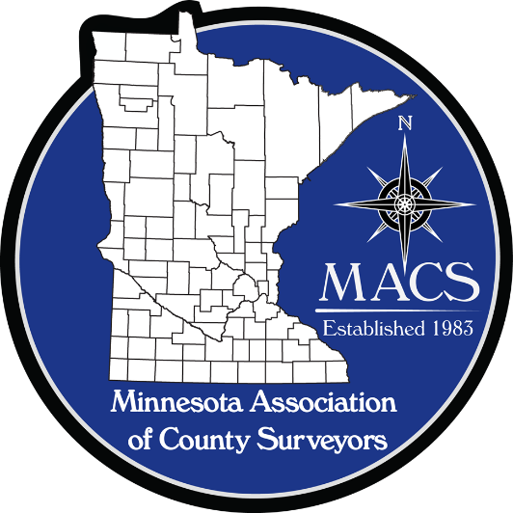 | SECRETARY/TREASURER  James Hentges  Scott County Surveyor  600 Country Trail East  Jordan, MN 55352  952-496-8362
PRESIDENT ELECT  Russ Heiling  Sherburne Co. Surveyor  13880 Business Center Drive  Elk River, MN 55330  763-765-3305 |  | DIRECTOR  Eric Schmitt  Houston County Surveyor  304 South Marshall Street  Caledonia, MN 55921  507 725-5814
PAST PRESIDENT  Patrick Veraguth  Douglas County Surveyor  536 Willow Drive  Alexandria, MN 56308  320-762-2964 |  | DIRECTOR  Nick Stewart  St. Louis County Surveyor  7823 Highway 135 East  Virginia, MN 55792  218-742-9823

www.macsinfo.org

MINUTES OF MEETING (APPROVED)
Minnesota Association of County Surveyors
May 10th, 2018
MACS Meeting at Olmstead County.
Tim Eklund called the meeting to order at 11:00 AM
Attendance: Steve Jobe, Russ Heiling, Tim Eklund, Robin Mathews, Pat Veraguth, Jim Hentges, Eric Schmitt, , Chuck Gitzen, Scott Marlin, Nick Stewart, Mark Severtson, Brian Praske, Chris Mavis, Rick Morey, Ed Kuisle, Tammy Mauss, Dale Lempke, Dick Walter, Roger Brand, Eric Stennes, Warren Delles, Jordan Kurth
Approval of Minutes: February 15th 2018. Motion – Robin Mathews. Second – Eric Schmitt. Approved.
March 14th 2018 Motion – Robin Mathews. Second – Eric Schmitt. Approved.
Membership Report: 40 Voting members and 6 Affiliate members.
State Board update: Robin Mathews reminded everyone to renew their license by June 30th.
MACS Committees:
Education Committee: Scott Marlin said nothing new for the education committee. Eric Fuller is moving forward with 4 year program.
Manual Committee: Brian Praske gave update. Brian reported that the draft R/W Manual is done and ready to distribute for comments. Comments should be back by May 31st. Brian to send to MACS Board and MSPS Board to distribute.

Membership Committee: Steve Jobe gave update. Dan McAninch is the new Crow Wing County Surveyor beginning May 21st 2018. Pat Veraguth noted that Scott Marlin is being appointed Morrison County Surveyor. Ben Madsen is new County Surveyor in Martin County. Steve Jobe reported there is some interest in members attending meetings by Skype. Pat Veraguth said he has a partial list of past MACS Presidents and Dick Walter also has some knowledge of past MACS Presidents.
New Business: Russ Heiling asked about guidelines for paying for lunch meetings for MACS. There was discussion on options. Might attract more people to meetings if lunch is part of meeting.
Supporting Activities: Tim Eklund opened discussion on supporting other organizations. The idea is to get MACS name out there and educate other groups on what MACS does. Chuck Gitzen suggested establishing a budget every year for this type of expense. Scott Marlin asked about minimum requirements for sponsoring activities. Robin Mathews made motion to determine a budget for sponsorships at the Board’s discretion. Second by Chuck Gitzen. Steve Jobe suggested checking bylaws. Bylaws state a budget be prepared and approved at the annual meeting. Robin and Chuck withdrew their motion.
PLS Committee: Pat Veraguth updated group on activities. Pat passed out a handout. Pat reported there is not much available for Legacy funding. Pat will be talking to County Recorders at the Recorders conference in June. Pat and others will also be talking at the GIS/LIS conference. Discussion on Remonumentation Manual. Robin Mathews volunteered to work on Remonumentation Manual. Discussion on Corner Certificates and minimum requirements. Chris Mavis suggested doing webinar or recording seminar to be able to share and put on website. Robin Mathews volunteered to do a one hour Corner Certificate seminar at MACS seminar.
Geomatics Committee : Jordan Kurth was asked to be involved in putting together workgroup by the 3D Geomatics Committee of MnGeo. The specific workgroup is “3D-derived Human Infrastucture workgroup” First meeting is on June 12th. Jordan asked if MACS would like to be involved on workgroup. Russ Heiling and Steve Jobe volunteered to be on committee.
Joint Meeting with Wisconsin: Pat Veraguth reported that some County Surveyors from Wisconsin may be able to join us at our July meeting. Robin Mathews to check with Lisa on meeting location.
Long Range Planning Committee: Motion by Robin Mathews to approve By-laws as amended. Second by Steve Jobe. By-laws approved as amended.
Wisconsin meet me at the corner meeting: Steve Jobe discussed the meeting format with the group. He said the meeting was very informative. Robin discussed who was involved in organizing the meeting. 70 plus people attended the meeting. Steve and Robin thought it was very beneficial. Chris Mavis volunteered to talk to the Geospatial Council about the concept. Pat Veraguth will also initiate the idea at the Recorders conference.
Seminar Committee: Seminar date is Tuesday October 30 with a strategic planning meeting on Wednesday October 31st Seminar topics for October seminar:
Rod Squires 1 hour on PLSS – Martinez 2 hours on Aerial photography – Robin Mathews 1 hour on 381.12 Corner Certificates – Pat Veraguth 1 hour on digging for section corners.

Other: Steve Jobe discussed Lee’s Monument kiosk on the state line and the needed repairs. Cost is approximately 240 dollars per side, total of approximately 480 dollars. This expenditure was approved previously.
Robin Mathews noted a surveying article in the Duluth news and an article written by Nick Stewart in the Hibbing Daily Tribune. See links on MACS website.
Rick Morey said that 11 people took the last Certified Survey Technician exam and asked if anyone would be able to administer and proxy exams.
Next Meeting: Next MACS meeting is scheduled for July. Location to be determined
Adjourn: Mark Severtson motion to adjourn. Russ Heiling second. Meeting adjourned.
Presentation: Dick Walter gave group presentation as Nathan Boone on the survey of Boundaries for the 1825 Treaty of Prairie du Chien. Thanks to Dick for informative presentation.

