PRESIDENT  Russ Heiling  Sherburne Co. Surveyor  13880 Business Ctr. Dr.  Elk River, MN 55330  763-765-3305 | 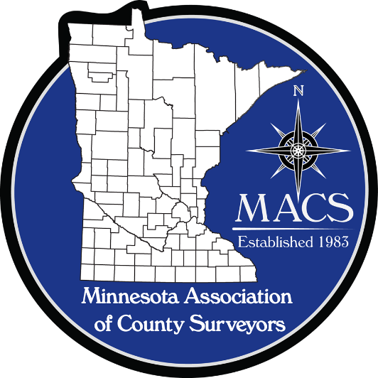 | SECRETARY/TREASURER  James Hentges  Scott County Surveyor  600 Country Trail East  Jordan, MN 55352  952-496-8362
PRESIDENT ELECT  Chuck Gitzen  Anoka Co. Surveyor  2100 3rd Ave. N., Rm 224  Anoka, MN 55303  763-324-3101 |  | DIRECTOR  Eric Schmitt  Houston County Surveyor  304 South Marshall Street  Caledonia, MN 55921  507 725-5814
PAST PRESIDENT  Tim Eklund  Deputy Hennepin  County Surveyor  300 South 6th Street  Minneapolis, MN 55487  612-348-2336 |  | DIRECTOR  Robin Mathews  Pine County Surveyor  405 Airport Rd. NE  Pine City, MN 55063  320-216-4205

www.macsinfo.org

MINUTES OF MEETING (UNAPPROVED)
Minnesota Association of County Surveyors
November 1st, 2019
MACS Strategic Planning Meeting at Sherburne County History Center.
Russ Heiling called the meeting to order at 10:00 AM
Attendance: Russ Heiling, Tim Eklund, Pat Veraguth, Chuck Gitzen, Pete Jenkins, Jim Hentges, Jason Blommel, Ryan Hennen
Seminar debrief/evaluation: Discussion on seminar.
Ethics session was good discussion. Attendees liked the panel discussion format.
Chuck Gitzen suggested having a session where school instructors can talk about their programs.
Final numbers for seminar. 172 total attendees. 90 students and instructors, 64 licensed, 18 technicians.
Discussion on having ethics presentation every year. Final consensus was to have 2 hours of ethics every other year.
Pizza social was good. Not as many students stuck around this year. Maybe because it was on Halloween this year.
Discussion on Seminar Certificates and maybe having a check list on the certificate for portions attended. Also emailing them to the attendees rather than putting out at afternoon break for people to pick up.
Suggestion to have instructors go through the classes required for their programs.
Discussion on developing group of mentors to discuss transition planning for getting technicians to licensure.

Discussion regarding class requirements and how St. Cloud State University is working with St. Cloud Technical & Community College to develop 4 year program.
Discussion about on-line programs.
Jim Hentges will scan and send out seminar evaluations.
Discussion on having strategic planning meeting on a different day than day after seminar.
2020 Proposed Budget approval:
Chuck Gitzen presented MACS budget for 2020.
Discussion on sandbox project. Chuck G. has talked to schools who said they may build one. MACS should ask if they could possibly build one for MACS too.
Discussion on MACS dues for 2020. Decided to leave dues the same as last year.
Evaluate Committees:
Russ H. discussed all committees and are they still valid or do they need to be revamped.
Discussion on Joint Education Committee. Eric Schmitt and Scott Marlin are on MACS committee.
Discussion on potential survey program at Mankato State college and how can we help them.
Discussion on Manual Committees. Working with MSPS on 505 Manual update. Also working on Remonumentation manual.
Membership Committee. Steve Jobe is heading up this committee.
Discussion on defining role and goals for each committee moving forward. Discussion on committee for AMC and State Board to monitor what is happening at these organizations.
PLSS Committee report: Pat Veraguth presented a handout with report on committee activities. See attached report.
Other: Discussion on filing Certificates of Corner Location. Pat V. said that the Grant County project being done by KLD and is anticipated to be completed by the end of 2020.
Next meeting: Next meeting is scheduled for December 10th at the AMC conference in St. Cloud. Discussion on staffing the MACS booth for the conference. Please talk to Russ H. if you are interested in helping with the booth. Booth hours are Monday Dec. 9 from 9-5 and Tuesday Dec. 10 from 9-noon. Need to order electrical service for booth. Discussion on 2020 MACS meeting schedule. Pat V. suggested a joint meeting with the Minnesota County Engineers Association (MCEA) this year.
Adjourn: Pat Veraguth motion to adjourn. Second by Jim Hentges.

