PRESIDENT  Tim Eklund  Dpty. Hennepin Co. Surveyor  300 South 6th Street  Minneapolis, MN 55487  612-348-2336 | 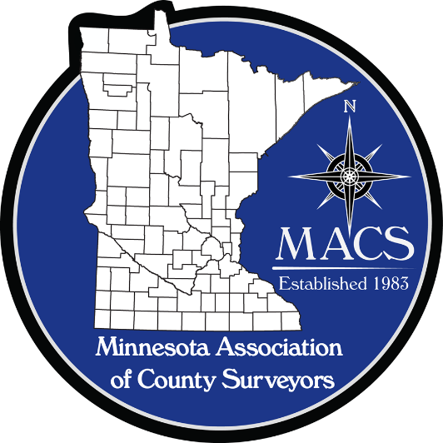 | SECRETARY/TREASURER  James Hentges  Scott County Surveyor  600 Country Trail East  Jordan, MN 55352  952-496-8362
PRESIDENT ELECT  Russ Heiling  Sherburne Co. Surveyor  13880 Business Center Drive  Elk River, MN 55330  763-765-3305 |  | DIRECTOR  Eric Schmitt  Houston County Surveyor  304 South Marshall Street  Caledonia, MN 55921  507 725-5814
PAST PRESIDENT  Patrick Veraguth  Douglas County Surveyor  536 Willow Drive  Alexandria, MN 56308  320-762-2964 |  | DIRECTOR  Nick Stewart  St. Louis County Surveyor  7823 Highway 135 East  Virginia, MN 55792  218-742-9823

www.macsinfo.org

MINUTES OF STRATEGIC PLANNING MEETING (APPROVED)
Minnesota Association of County Surveyors
October 31, 2018
MACS STRATEGIC PLANNING Meeting at Stearns County.
Tim Eklund called the meeting to order at 9:00 AM
Attendance: Steve Jobe, Russ Heiling, Tim Eklund, Pat Veraguth, Jim Hentges, Pete Jenkins, Scott Marlin, Mark Severtson, Dan McAninch, Julie Groetsch, Jared Kotasek, Eric Schmitt, Tammy Mauss, Chris Mavis, Denny Pederson.
Introductions:
2018 Seminar Debrief:
Microphone could be better.
Topics were good. Discussion on new topics. Topics for next year. Should we get ideas from instructors.
How can we make seminar more interactive. Sandbox was a good idea, initiated conversation.
Could have a Question and Answer panel or questions from students sent in prior to seminar.
Have filler material available. Could have a video ready for filler if needed.
Sandbox was very popular.
More food.
Discussion on Ethics. Could possibly split up seminar with a 2 hour ethics breakout with round table discussion.
Trivia questions for all with reply by smart phones.

2019 Proposed meeting schedule: - February at MSPS Annual Meeting, April, June, August, October, and December at AMC Conference. Discussion on meeting at MnDOT Survey Technical Workshop. Decision made to not meet at MnDOT Survey Technical Workshop this year due to low attendance.
Meeting at AMC building in St. Paul in August: Group discussed possibility of meeting in August at the AMC building in St. Paul
2019 Proposed Budget: Group discussion on expenses and revenues. MACS Board set and approved budget for 2019.
2019 MACS Dues: Discussion on MACS dues for 2019. Dues was set to 80 dollars for Voting members and 50 dollars for Affiliate members. This includes membership to National Association of County Surveyors also.
Discussion of 2019 Goals for MACS: Discussion on goals for 2019.
Meet me at the Corner. This was well received at the GIS/LIS meeting and should plan for in 2019.
Remonumentation of the PLSS. Preston Dowell discussed talked about the status map. Preston explained map and what the purpose of the map is and how it could be used. Preston would be willing to consolidate information. Preston volunteered to send out letter with specifics on format etc. for those contributing information on PLSS. Pat Veraguth is putting a group together to continue work on PLSS funding etc. Pat reported they are still waiting for approval of Grant County project. Pat stated that Wilken County is also doing a township corner project. It was suggested that a handout be prepared for distribution at the AMC Conference booth. There was discussion on administrative issues for the Grant County project. Who is the contact and other issues to finalize.
Joint Meeting with MACS, MSPS and MSES on supporting Civil Tech fields: Chris Mavis representing MSPS talked about MSPS financial support of Education. Primary duty of the MSPS Foundation committee is scholarships for students in both 2 year and 4 year programs. Also working with the Education Committee. Chris also talked about Future Cities Competition and STEM support by MSPS.
Tim Eklund discussed MACS support of students through MACS seminars and Future Cities Competition financial support.
Mark Dierling (SEH) and Jason Staebell (Hennepin County) representing Minnesota Society of Engineers and Surveyors. (MSES) Mark discussed MSES. He noted that 2020 will be the 125th year anniversary of the organization. Mark stated the primary purpose of the organization is to raise money and provide scholarships. They have been focused on transportation engineering lately. They provide $1,000 to $2,000 dollar yearly scholarships with approximately $30,000 to $40,000 dollars a year total. They will be having their strategic planning meeting next month. Their dues are $40.00 dollars annually. They have several fundraisers throughout the year. They have a fall outing, a winter event and a golf tournament in June. Mark noted that Transportation Engineering numbers are declining. There was discussion on how the groups can work together to promote and support the industry. MSES strategic planning meeting in November. MSES usually meets every other month. It would be best to meet after the new year for next steps to working together.

Other: Steve Jobe noted that Robin Mathews and Preston Dowell are presenting at the MnDOT Survey Technical Workshop in March. Steve asked for other presentations if anyone is interested in presenting.
There was discussion of having a National Association of County Surveyors (NACS) meeting in Minnesota sometime.
Next Meeting: Next MACS meeting at AMC Conference on December 4th, 2018.
Meeting adjourned.

