PRESIDENT  Tim Eklund  Dpty. Hennepin Co. Surveyor  300 South 6th Street  Minneapolis, MN 55487  612-348-2336 | 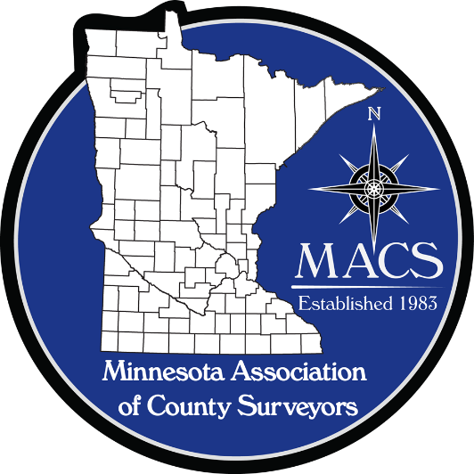 | SECRETARY/TREASURER  James Hentges  Scott County Surveyor  600 Country Trail East  Jordan, MN 55352  952-496-8362
PRESIDENT ELECT  Russ Heiling  Sherburne Co. Surveyor  13880 Business Center Drive  Elk River, MN 55330  763-765-3305 |  | DIRECTOR  Eric Schmitt  Houston County Surveyor  304 South Marshall Street  Caledonia, MN 55921  507 725-5814
PAST PRESIDENT  Patrick Veraguth  Douglas County Surveyor  536 Willow Drive  Alexandria, MN 56308  320-762-2964 |  | DIRECTOR  Nick Stewart  St. Louis County Surveyor  7823 Highway 135 East  Virginia, MN 55792  218-742-9823

www.macsinfo.org

MINUTES OF MEETING (APPROVED)
Minnesota Association of County Surveyors
September 11, 2018
MACS Meeting at Pine County.
Tim Eklund called the meeting to order at 10:04 AM
Attendance: Steve Jobe, Russ Heiling, Tim Eklund, Robin Mathews, Pat Veraguth, Jim Hentges, Lisa Hanni, Reese Frederickson Pine County Attorney, Pete Jenkins, Preston Dowell, Nick Stewart, Scott Marlin, Warren Delles, Chuck Gitzen.
Approval of Minutes: July 25, 2018. Motion – Robin Mathews. Second – Patrick Veraguth. Approved.
Tim Eklund stated he talked with Dan Baar and Dan provided some Land Surveyor statistics from the State Board. Information such as number of Land Surveyors, age distribution and gender numbers. Tim will check to see if we can put information on our website.
Secretary/Treasurer Report: 42 Voting members and 6 Affiliate members. Currently have $18,134.35 in the bank account.
MACS Committees:
Education Committee: Scott Marlin updated group on numbers of surveying students at St. Cloud Technical College (SCTC). He said there are 20 2nd year students and 27 1st year students. St Cloud State University has 16 returning students and 20 new students in the program. The program is continuing at this time. General discussion on ways to get the word out about Land Surveying as a profession. Scott reported that all students at SCTC had internships in surveying for the summer and surveying jobs at graduation for all students. Discussion on how to reach out to the technical programs. Robin Mathews and Jim Hentges offered to get school contact information to Scott Marlin.

PLS Committee: Pat Veraguth updated group on activities. Pat also reported that Lawrence Township in Grant County received approval from the LCCMR committee for a grant of $135,000.00 for PLSS work. Pat submitted a presentation for the AMC conference but was not accepted.
Seminar update: Discussion on seminar topics and finalizing them. Topics include Aerial Imagery Acquisition Mission Planning, Ramsey County Right of Way project, Section Corner Excavation, Center of Section Presentation, Public Land Survey System, Right of Way Manual overview. Preston Dowell will check with Young Professionals group about pizza social after the seminar. Tim Eklund asked about other options for lunch and providing cookies for afternoon break. Jim Hentges to check on options. Discussion on MACS strategic planning meeting.
Future of Surveying maps: Lisa Hanni has future of surveying maps that can be used for educational purposes. Tim Eklund made motion to get 50 maps of each version. Robin Mathews 2nd the motion. Motion approved for 100 maps.
Meet me at the Corner: Preston Dowell updated the group. There will be a presentation of meet me at the corner at the GIS/LIS Conference. Preston reported that 25 – 30 people have signed up. Preston Dowell, Pat Veraguth, Robin Mathews and Rod Squires are all presenting at the GIS/LIS conference.
Initial Point Maintenance: Tim Eklund updated group on maintenance of the initial point location. General consensus of the group was that we should support maintenance at the location. This will be an item for the Strategic Planning meeting and budget discussions.
ROW Plat Manual: Chuck Gitzen reported that the manual is almost completed. Pete Jenkins provided information on acquiring right of way on Indian lands.
Future Cities sponsorship and support: Steve Jobe updated group on this year’s event. The competition will be in January. Robin Mathews volunteered to be a judge at the competition. Steve asked for volunteers and to support Future Cities Competition with sponsorship for $500.00. Robin Mathews made motion to provide sponsorship for $500.00. Second by Scott Marlin. Motion approved.
MACS/MSPS Request to form working group for NATRF2022: Tim Eklund attended meeting of Wisconsin group that is formed to follow NATRF2022. There was much discussion on moving to the new datum. Discussion on what is happening and how involved we need or want to be. MnDOT is doing some analysis and is the contact for the state on the project. Preston provided handout.
Future of Surveying Forum group: MACS had agreed to sponsor room rental for the group meeting in September.
AMC Presentation: Russ Heiling and Tim Eklund went to Isanti County to talk about County Surveyors and what they can do. Russ has tried to talk to Suzanne Morris about an AMC Conference presentation on County Surveyors. Tim Eklund talked on role of County Surveyors. Discussion on putting together information on what County Surveyors can do for other departments. Discussion on putting information on MACS website for use by all.
Other: Preston Dowell initiated discussion on having a Land Surveyor on the MN GIS/LIS Board. He was asked about the possibility by the GIS/LIS Board. Position would have to be approved by the GIS/LIS Board. Preston also suggested having a Land Surveyor on the MN Geospatial Board. Group thought it would be beneficial to pursue.

Pete Jenkins stated that MnDOT has a project that will destroy a Judicial Land Mark and what process to use to preserve location. Pete is putting together a process for review by Torrens Examiners.
Next Meeting: MACS Strategic Planning meeting is scheduled for October 31st at Stearns County.
Adjourn: Preston Dowell motion to adjourn. Robin Mathews second. Meeting adjourned.

